**1. Read the fact file. Then complete the sentences about Andrew with the correct form of the verbs “be”, “have”, “like” and “can”.**

Fact file

**Name:** Andrew

**Age:** 36

**Country:** Argentina

**Marital Status:** Girlfriend

**Height:** tall

**Weight**: thin

**Hair:** short wavy brown

**Eyes**: brown

**Character:** friendly and cheerful.

**Siblings:** one sister and three brothers

**Pets:** dog (Toby)

**Interests and hobbies:** Football and Tennis

**Abilities:** Drive

**Weaknesses:** speak English



Hello! This is my dad Andrew. He ___is_____ 36 years old. He __has_ a girlfriend. He _is___ tall and thin. He ___has____ short wavy brown hair and brown eyes. He ____is__ very friendly and cheerful. He ____has__one sister and three brothers. He _has____a dog called Toby. He _enjoys__ playing football and tennis in his free time. He __can__drive but he __he____ speak English.

**2. Now complete the fact file and write a paragraph about you.**

Fact file

**Name:** Bryan

**Age:** 18

**Country: Colombia**

**Marital Status:Relationship**

**Height:** 1.75

**Build**: 70 kg

**Hair:** Black

**Eyes**: **Dark brown eyes**

**Character:friendly**

**siblings:** one

**Pets:** one dog and three cats

**Interests and hobbies:drawings**

**Strengths: play videogames**

**Weaknesses:irresponsible**

Paste your picture

Hello! My name is _ Bryan, I'm 18 years old, I really like playing games and drawing, I'm in a relationship and my dream is to be a programmer. Fear one seventy five, I weigh seventy kilos my hair is black, I have dark brow eyes I have a half brother, I have three cats and dog, and my wearkness is being irresponsible.

__________________________________________________________________________________________________________________________________________________________________________________________________________________________________________________________________________________________________________________________________________________________________________________

**3. Write questions, using the personal pronoun “you” or the possessive adjective “your” then ask your partner and complete the fact file below.**

* Name: What’s your name?
* Age:
* Country of origin:
* Marital status:
* Physical appearance:
* Personality:
* siblings:
* Pets:
* Hobbies:
* Abilities:
* Weaknesses

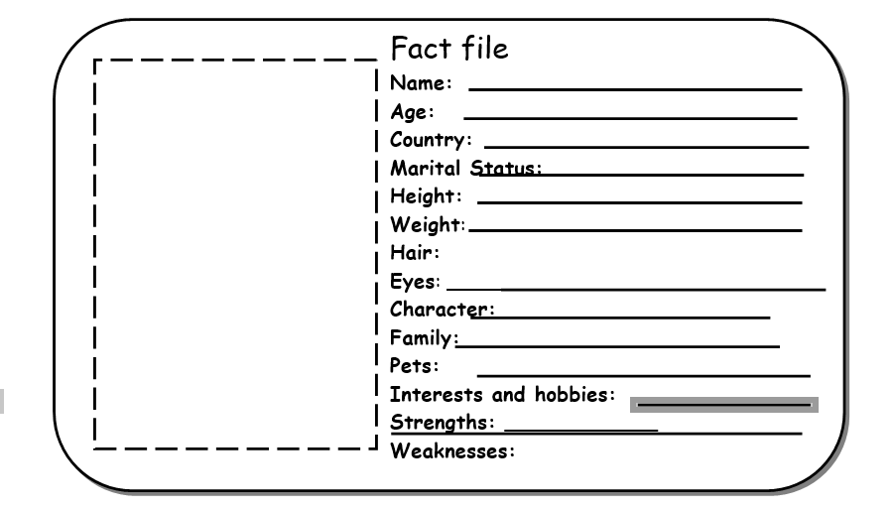

Paste your parter’s picture.

**4. Now write a paragraph about your partner.**

This is _____________________________________________________________________

__________________________________________________________________________________________________________________________________________________________________________________________________________________________________________________________________________________________________________________________________________________________________________________